Question 1 – Queries & Results

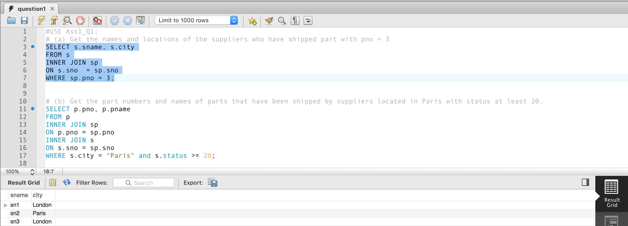

Figure 1: Answer to Q1/a

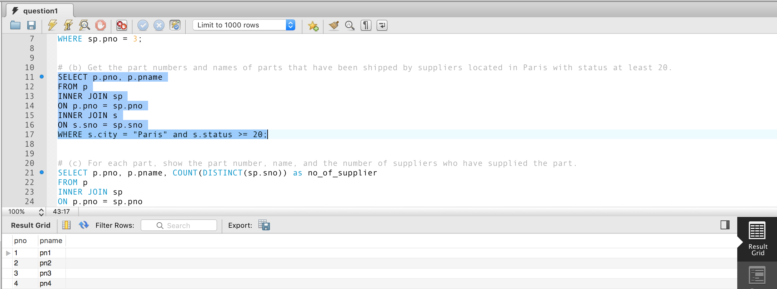

Figure 2: Answer to Q1/b

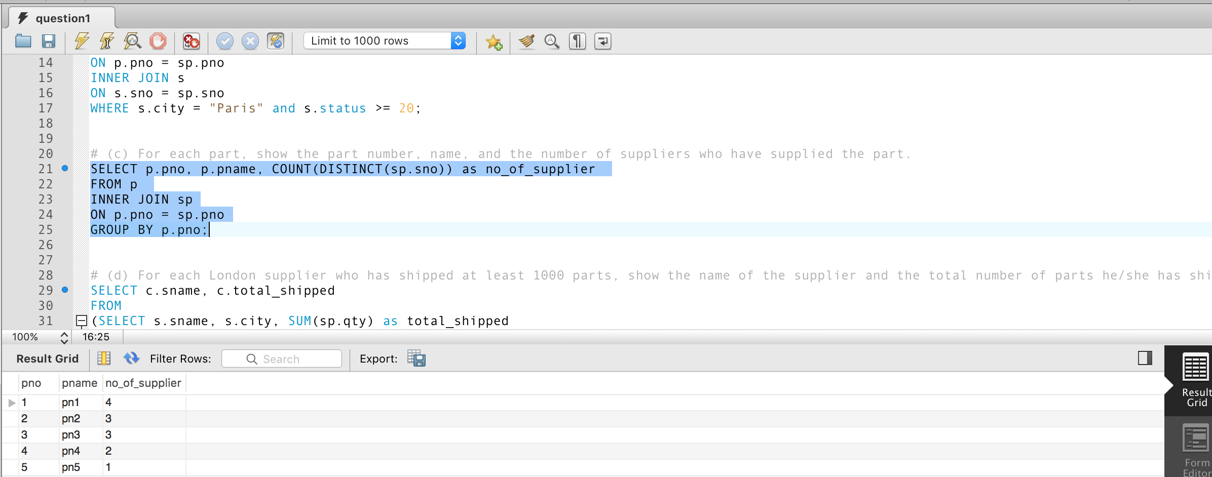

Figure 3: Answer to Q1/c

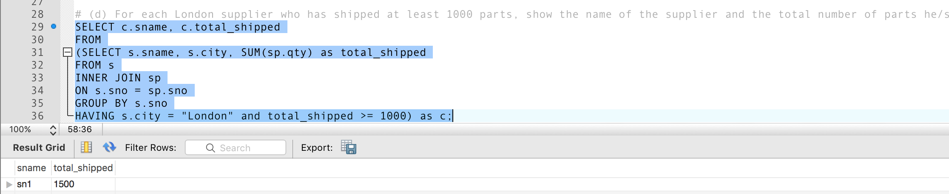

Figure 4: Answer to Q1/d

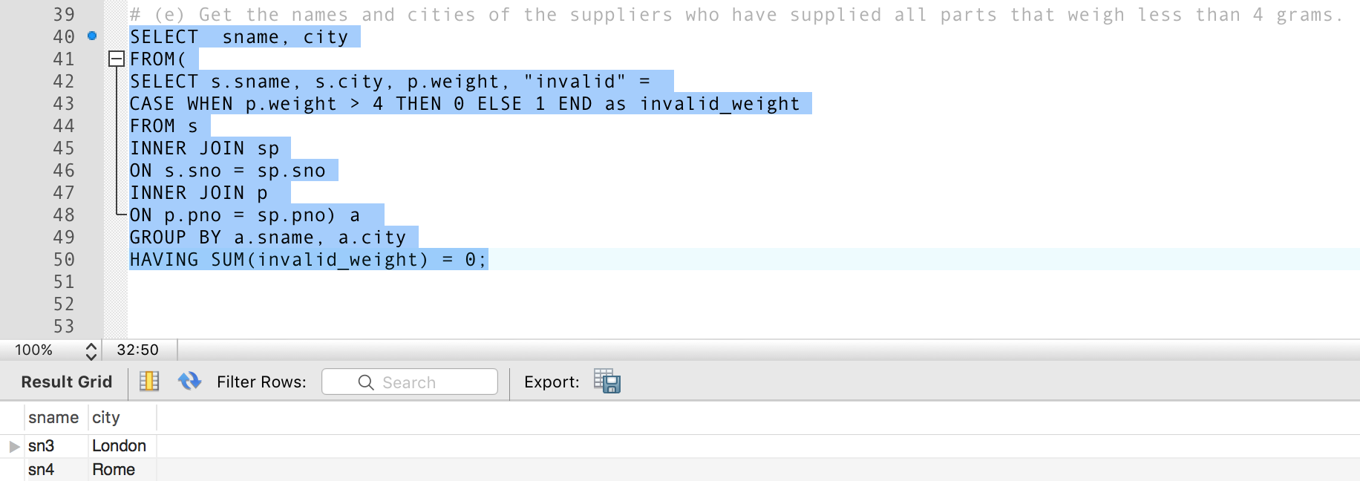

Figure 5: Answer to Q1/e